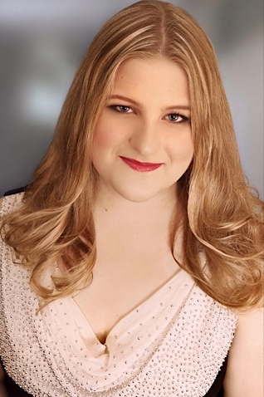Katherine Dobbs Mezzo-Soprano

|  |  |  |  |
| --- | --- | --- | --- |
| **ROLES** |  |  |  |
| Ježibaba | *Rusalka* | LAH-SOW | Ant. 2023 |
| Ottavia | *L’incoronazione di Poppea* | The Shepherd School of Music | Ant. 2023 |
| Mrs. Jones | *Street Scene* | The Shepherd School of Music | 2022 |
| Miss Todd* | *The Old Maid and the Thief* | Opera Project Columbus | 2022 |
| Orfeo | *Orfeo ed Euridice* | DePauw School of Music | 2022 |
| Miss Todd | *The Old Maid and the Thief* | DePauw School of Music | 2021 |
| Die Knusperhexe | *Hänsel und Gretel* | DePauw School of Music | 2020 |
| Miss Marietta Shingle | *A Gentleman’s Guide to Love and Murder* | DePauw School of Music | 2019 |
| Madame de la Haltière | *Cendrillon* | DePauw School of Music | 2019 |

**\*** Denotes Cover

|  |  |  |  |
| --- | --- | --- | --- |
| **ROLES (SCENES)** |  |  |  |
| Addie | *Regina* | The Shepherd School of Music | Ant. 2022 |
| Alisa | *Lucia di Lammermoor* | The Shepherd School of Music | Ant. 2022 |
| Carmen | *Carmen* | DePauw SoM Opera Scenes | 2020 |
| Dalila | *Samson et Dalila* | DePauw SoM Opera Scenes | 2020 |

|  |  |  |
| --- | --- | --- |
| **COMPETITIONS & AWARDS** |  |  |
| Houston Gilbert & Sullivan Society’s 2023 Vocal Career Grant Competition | 2nd place winner out of 10 finalists | 2023 |
| G. Hans Grueninger German Award | “Outstanding work in German and German Studies Courses” | 2022 |
| Pi Kappa Lambda (Inducted as undergrad junior) | “For the highest level of musical/academic achievements” | 2021 |
| Meghan Parker Award | “For the most Outstanding 1st Year Vocalist at the DePauw SoM” | 2019 |
| Miller Family Music Education Scholarship | “Awarded for musical/community involvement & good citizenship” | 2018 |

|  |  |  |
| --- | --- | --- |
| **TRAINING & EDUCATION** |  |  |
| Rice University | M.M., Vocal Performance | Ant. 2024 |
| Music Academy of the West | Studio Artist | Summer 2023 |
| LAH-SOW Rusalka Workshop | Young Artist - Ježibaba | Summer 2023 |
| Dolora Zajick’s IYDV | Young Artist | Summers ’20, ’21, ‘22 |
| DePauw University | B.M., Vocal Performance  German & Italian minors | 2022 |

|  |  |  |  |  |
| --- | --- | --- | --- | --- |
| **TEACHERS** | **DIRECTORS** | **COACHES** | **CONDUCTORS** | **CLASSES** |
| Darrell Babidge | Susan Anthony | Ed Bak | Kevin Meidl | Darrell Babidge |
| Luana DeVol | Audrey Chait | Stefano Baldasseroni | Steven Osgood | Barbara Hill-Moore |
| Carol Jegen | Cara Consilvio | Marianne Barrett | Eric Schmidt | Kevin Massey |
| Kerry Jennings | Pat Diamond | Beatrice Benzi | Orcenith Smith | Thomas Muraco |
| Thomas King | Kerry Jennings | Cheryl Fielding | Gary Wedow | Kelli O’Hara |
| Badiene Magaziner | A. Scott Parry | Amanda Hopson |  | Lisette Oropesa |
| Robin Rice (current) |  | Luke Housner (current) |  | Laura Osnes |
| Caroline Smith |  | Yelena Kurdina |  | Patrick Summers |
| Monica McCullough |  | Kathryn LaBouff |  |  |
| Dolora Zajick |  | Thomas Muraco |  |  |
| **RELATED SKILLS** | | | | | |
| Blackbelt (karate); armed/unarmed stage combat 4 yrs; ballroom dance 4 yrs; roller-skating; acting classes 4 yrs; dialects (Irish New York, Cockney); improvisational classes/troupe 4 yrs, piano 10 yrs; varying comprehensions of French, German, and Italian | | | | | |